In [2]:

*#Visualize the data using Python libraries matplotlib, seaborn by plotting the graphs for assignment no. 2 and 3 ( Group B) #import dependencies*

**import** matplotlib.pyplot **as** plt

**import** seaborn **as** sns

**import** numpy **as** np

**import** pandas **as** pd

In [3]:

df**=** pd.read_csv('heartdisease.csv')

In [4]:

df.head(5)

|  |  |  |  |  |  |  |  |  |  |  |  |  |  |  |
| --- | --- | --- | --- | --- | --- | --- | --- | --- | --- | --- | --- | --- | --- | --- |
| Out[4]: | **age** | **sex** | **cp** | **trestbps** | **chol** | **fbs** | **restecg** | **thalach** | **exang** | **oldpeak** | **slope** | **ca** | **thal** | **num** |
|  | **0** 63 | 1 | 1 | 145 | 233 | 1 | 2 | 150 | 0 | 2.3 | 3 | 0 | 6 | 0 |
|  | **1** 67 | 1 | 4 | 160 | 286 | 0 | 2 | 108 | 1 | 1.5 | 2 | 3 | 3 | 2 |
|  | **2** 67 | 1 | 4 | 120 | 229 | 0 | 2 | 129 | 1 | 2.6 | 2 | 2 | 7 | 1 |
|  | **3** 37 | 1 | 3 | 130 | 250 | 0 | 0 | 187 | 0 | 3.5 | 3 | 0 | 3 | 0 |
|  | **4** 41 | 0 | 2 | 130 | 204 | 0 | 2 | 172 | 0 | 1.4 | 1 | 0 | 3 | 0 |
| In [6]: |  |  |  |  |  |  |  |  |  |  |  |  |  |  |

In [18]:

*#Barplot using seaborn*

sns.barplot(x**=**'sex', y**=**'thalach', data **=** df)

Out[18]: <AxesSubplot:xlabel='sex', ylabel='thalach'>

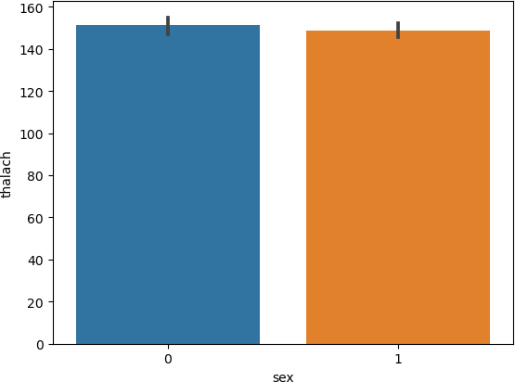

In [20]:

*#ScatterPlot using seaborn*

sns.scatterplot(x**=**'age', y**=**'thalach', data **=** df)

Out[20]: <AxesSubplot:xlabel='age', ylabel='thalach'>

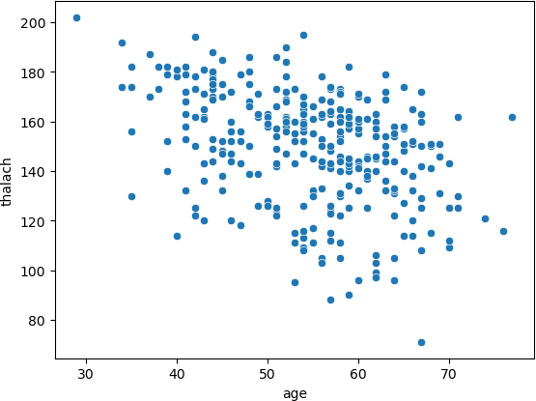

In [17]:

*#Lineplot using seaborn*

sns.lineplot(x**=**'sex', y**=**'age', data **=** df)

Out[17]: <AxesSubplot:xlabel='sex', ylabel='age'>

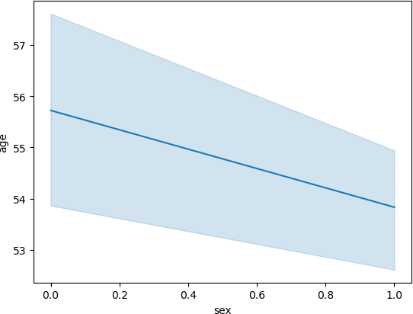

In [29]:

*#Pairplot using seaborn*

plt.figure(figsize**=**(12,12))

sns.pairplot(df, hue**=** 'sex' , palette **=** 'Blues')

Out[29]: <seaborn.axisgrid.PairGrid at 0xde46aadfd0>

<Figure size 1200x1200 with 0 Axes>

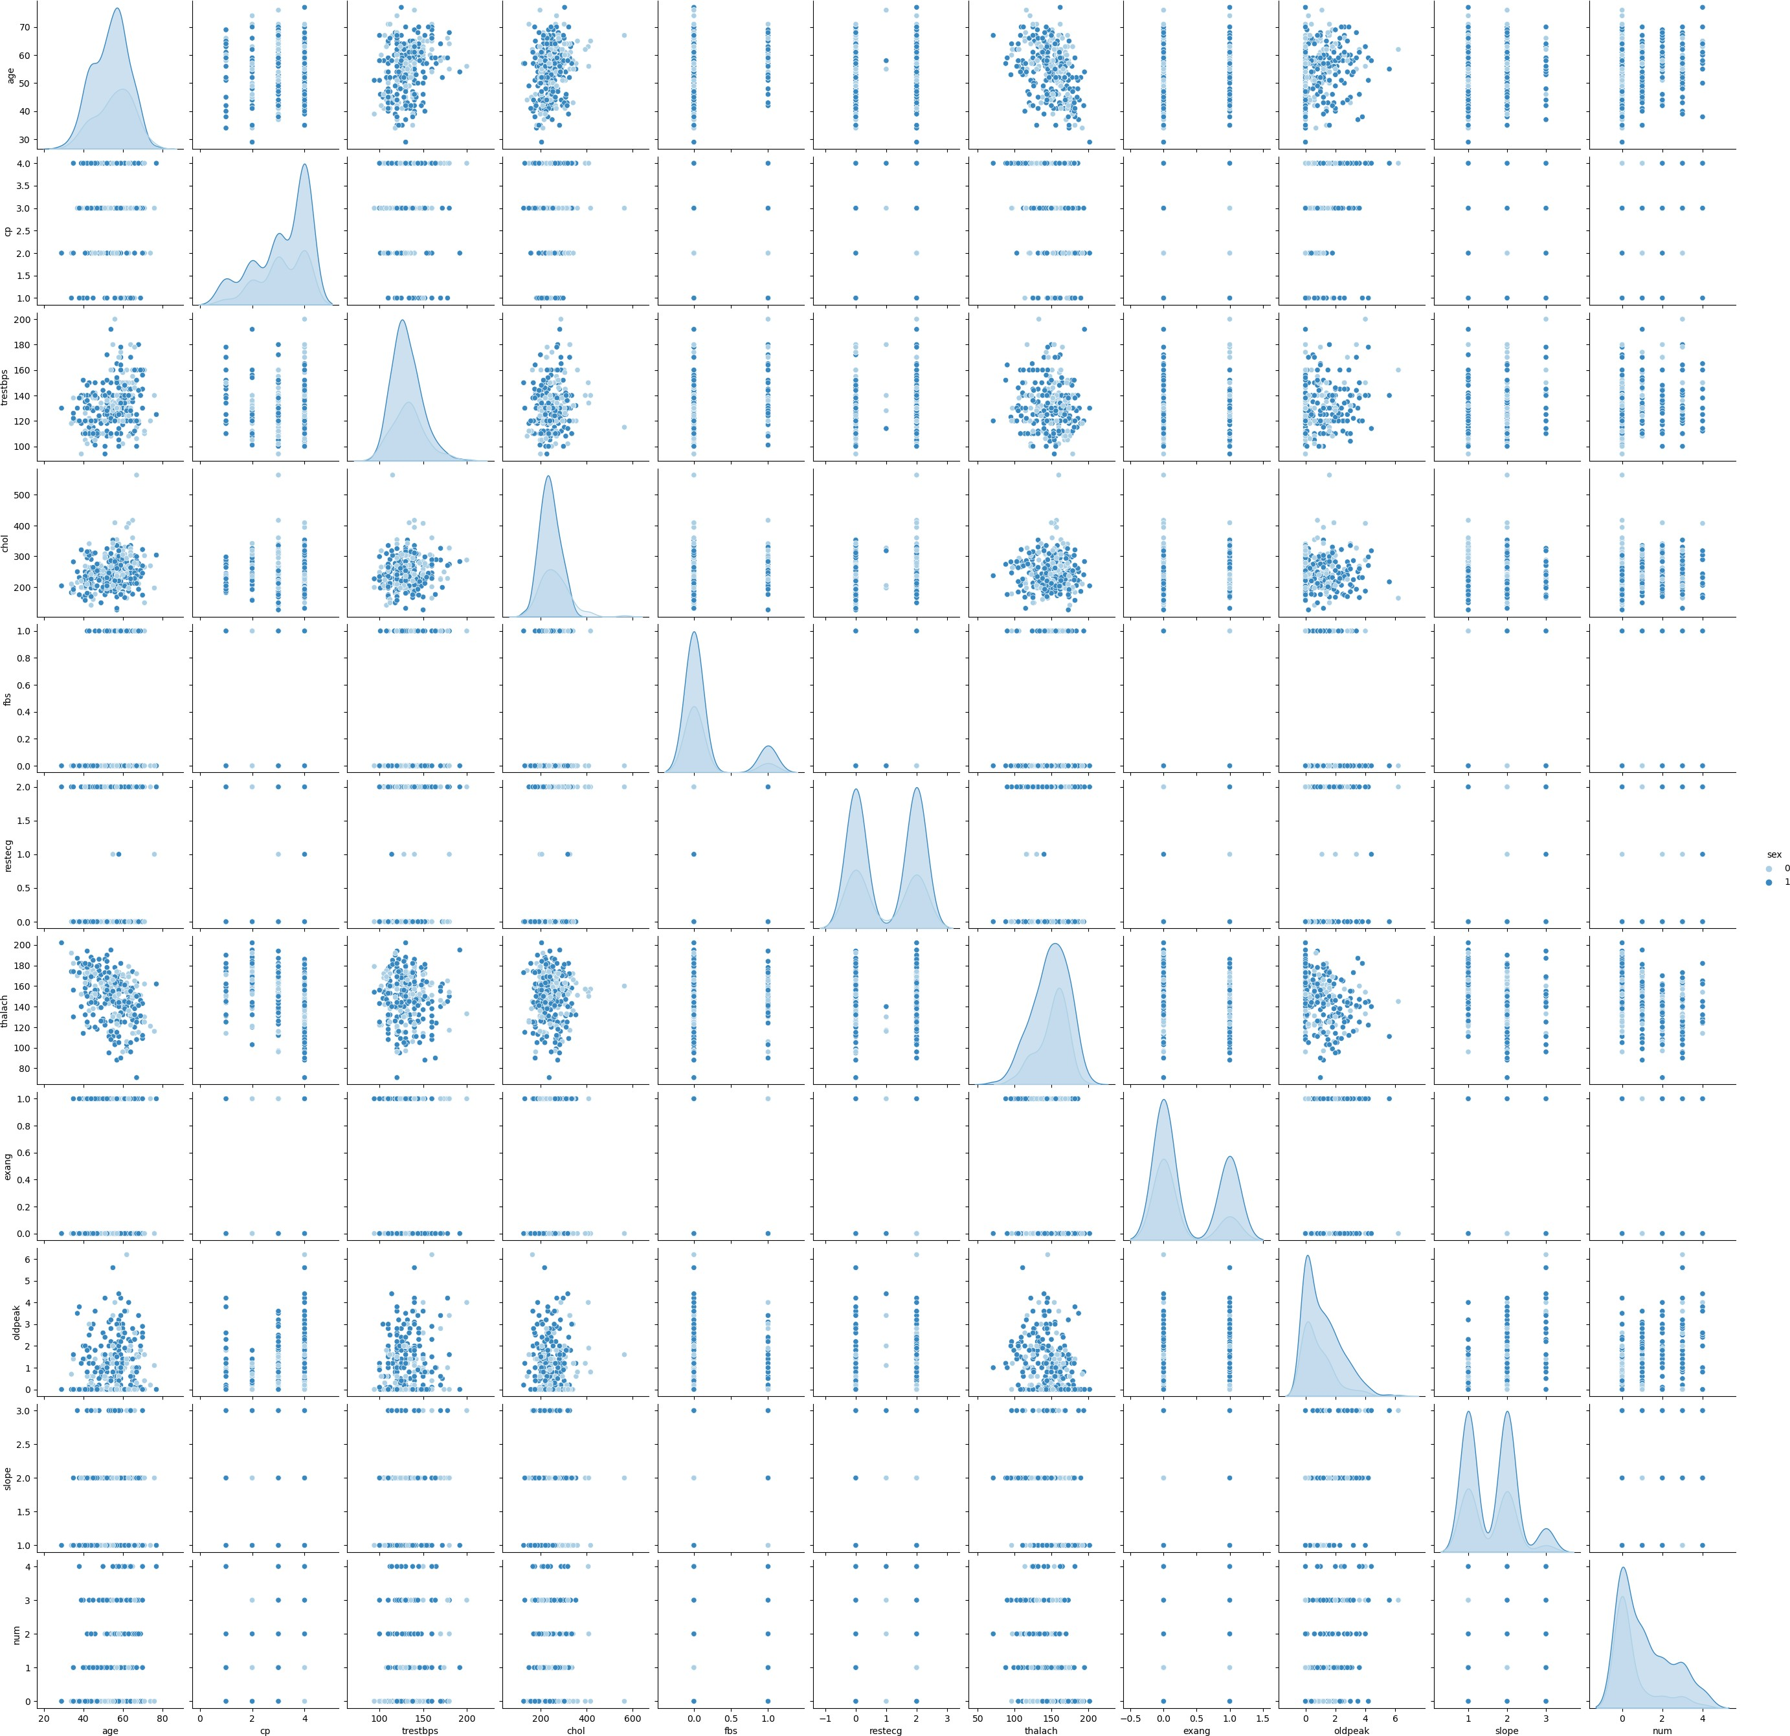

In [25]:

*#Displot using seaborn*

sns.displot(df['thalach'])

Out[25]: <seaborn.axisgrid.FacetGrid at 0xde2fc6dd60>

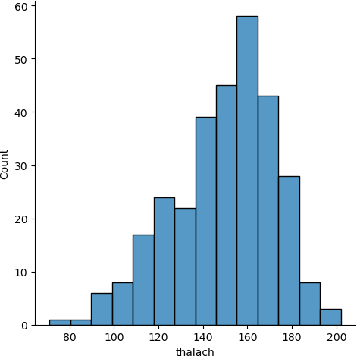

In [35]:

*#ScatterPlot using Matplotlib*

plt.scatter(df['thalach'], df['age']) plt.show()

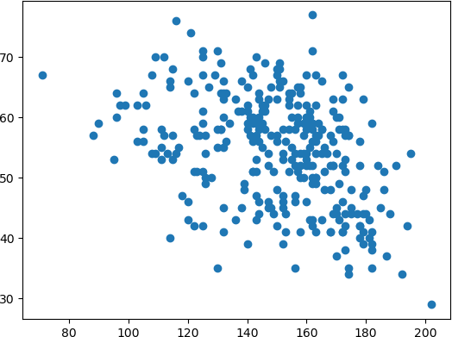

In [ ]:

In [ ]:

In [45]:

*#PiePlot using Matplotlib*

sex_df **=** pd.DataFrame(df['sex'].value_counts()) sex_df

Out[45]: **sex 1** 206

**0** 97

In [46]:

plt.pie(sex_df['sex'], labels **=** sex_df.index)

Out[46]: ([<matplotlib.patches.Wedge at 0xde3716a3d0>,

<matplotlib.patches.Wedge at 0xde3716a850>],

[Text(-0.5890242258008583, 0.9290050922463771, '1'),

Text(0.5890242258008579, -0.9290050922463774, '0')])

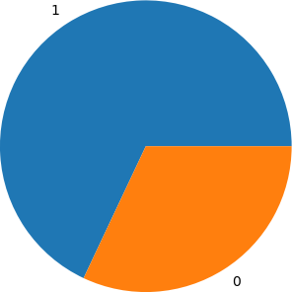

In [47]:

*#Barplot using Matplotlib*

plt.bar(sex_df.index, sex_df['sex']) plt.show()

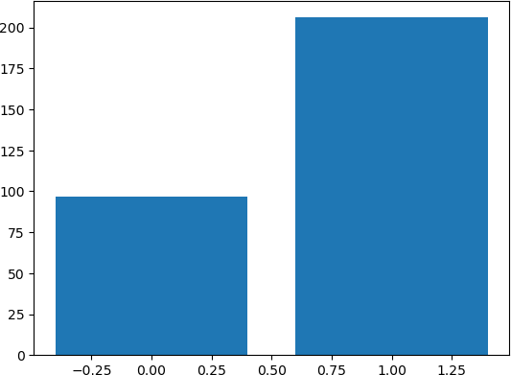

In [ ]: